## Supporting Documentation

### Proof of W3C Validation:

The HTML and CSS files were validated using the W3C Markup Validation Service https://validator.w3.org/

##### Online Learning Platform (home.ejs):

The homepage HTML was validated using the W3C Markup Validation Service. The code passed with no errors or warnings.

##### Explore Our Courses (courses.ejs):

The Courses page was successfully validated using the W3C Markup Validation Service. URL-encoding fixed earlier issues with spaces in href attributes. The page now fully complies with W3C standards, ensuring clean, accessible, and semantically correct HTML.

##### Meet Our Instructors (instructors.ejs):

The "Instructors" page has been reviewed and updated to meet W3C standards. A proper heading was added to improve semantic structure and accessibility. The page now passes validation successfully and is fully functional in the final website.

##### Live Sessions & Events (events.ejs):



The Events page has been successfully validated using the W3C Markup Validation Service. All previous errors have been resolved, and the page now fully conforms to W3C standards, ensuring clean, accessible, and well-structured HTML.

##### Frequently Asked Questions (faq.ejs):



The FAQ page was successfully validated using the W3C Markup Validation Service. All previous issues have been resolved, and the page now fully complies with HTML standards. This ensures improved accessibility, clean structure, and compatibility across modern browsers.

##### Interactive Quiz (quiz.ejs):

The quiz page HTML was validated using the W3C Markup Validation Service. The code passed with no errors or warnings.

##### Contact Us (contact.ejs):



The Contact page was validated with the W3C Markup Validation Service and passed without any errors or warnings, confirming that the HTML is well-structured and standards-compliant.

### Feature Explanation (Event Registration):

1. Client-side: The user fills out a form with their name and email to register for a selected event.

JavaScript is used to handle validations.

1. Server-side: On submission, the form sends data to the Express.js server which then inserts it

into an SQLite database (table: registrations). A confirmation email is also sent via NodeMailer.

### Legal and Ethical & Accessibility Considerations:

- All images used were sourced from royalty-free websites such as Pexels and Unsplash.

- Accessibility considerations include: use of alt text for images, proper semantic HTML elements

(headers, nav, sections), and keyboard navigable forms.

### Security Considerations:

- User inputs are sanitized before being inserted into the database.

- The SQLite database is stored securely within a data/ directory.

- Emails are sent using app-specific passwords (if Gmail is used).

### ERD Diagram:

An Entity Relationship Diagram (ERD) has been generated on <https://app.diagrams.net/>. It outlines the 'contact', 'registrations', and 'course_registrations' tables and

their relationships.

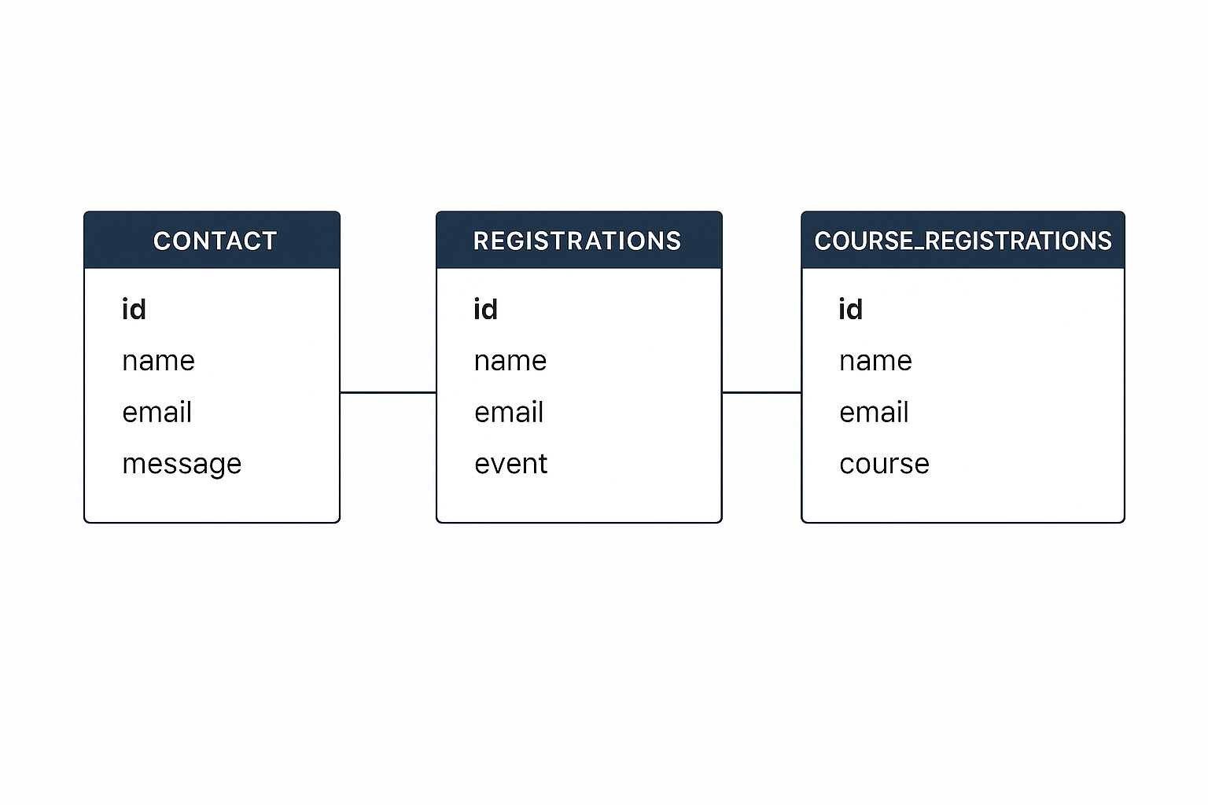

### Version Control:

The project has been maintained using Git and pushed to GitHub under the username:

Tamarakira <https://github.com/Tamarakira/Web-Technologies-Practical-1.git>

### AI Tool Usage Disclosure:

Tool: ChatGPT by OpenAI.

These tools were occasionally used to help troubleshoot specific validation issues, format improvements, and project organization tips. All core logic, styling, and structural decisions were made by the developer.

### Learning Resources Used

Some guidance was also taken from online documentation and tutorials, particularly from https://www.w3schools.com/, which supported HTML, CSS, and JavaScript usage.